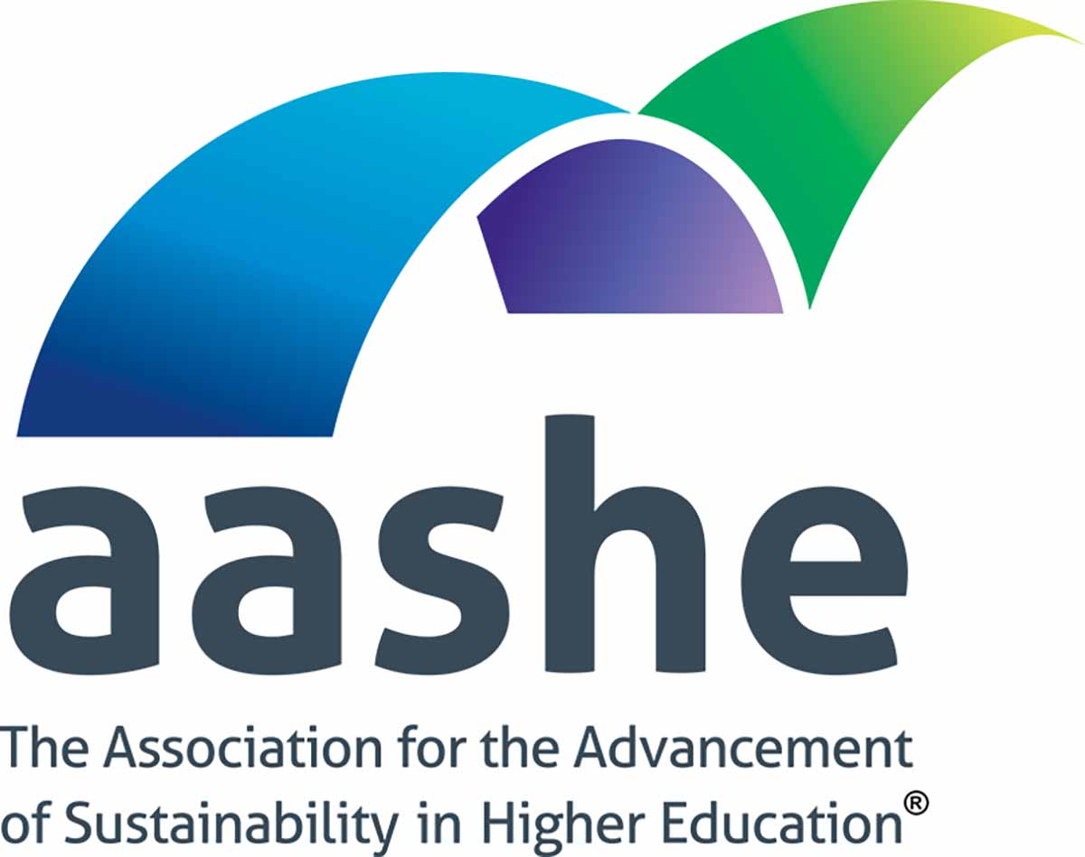

2021 Call for Educational Content
Proposal Submission Template

Full information is available at: http://www.aashe.org/education including the Submission Packet.

Create a Proposal Submission Template
- Required steps are noted with a red asterisk (*) and must be completed before submitting your proposal.
- Steps or answer choices highlighted in light green include a logic option, meaning that the answer will impact the fields you are asked to complete.
- Word and character limits are highlighted in light blue.
You can save your incomplete proposal at any time by clicking on . You will be emailed a link to access your saved proposal. Please double-check spelling and grammar prior to finalizing as errors may carry through into the final program if your proposal is accepted.

Page 1: Submitter Information
- *First Name
- *Last Name
- *Primary Email
- *Best Phone Number
- *Position/Role
- *Organization
- *Are you or any of your co-presenters affiliated with an AASHE member organization? AASHE membership is required to present an AASHE webinar, workshop or course and is not required to present at the conference.
  - Yes
  - No
  - I am not sure
- *Would you be a presenter for the educational program you are proposing?
  - Yes, I would be the sole presenter (skip Page 2)
  - Yes, I would be a presenter and there would be additional presenters (please add their information on the next page)
  - No, I am submitting on behalf of the presenter(s) (please add their information on the next page

Page 2 - Presenter Information
Enter information about the presenter and, if applicable, co-presenter(s). Please note, up to four presenters can be associated with a session (or one submitter and four presenters). Please double check that the email addresses provided are correct. If an email address is incorrect, they will not receive important information. The presenters added on this page will receive an email notifying them that they were included on this proposal.
- *Presenter 1 - First Name
- *Presenter 1 - Last Name
- *Presenter 1 - Primary Email
- *Presenter 1 - Best Phone Number
- *Presenter 1 - Position/Role
- *Presenter 1 - Organization
- *Presenter 2 - Would you like to add another presenter?
  - Yes (show Presenter 2 questions)
  - No (go to Page 3)
- Presenter 2 - First Name
- Presenter 2 - Last Name
- Presenter 2 - Primary Email
- Presenter 2 - Best Phone Number
- Presenter 2 - Position/Role
- Presenter 2 - Organization
- Presenter 3 - Would you like to add another presenter?
  - Yes (show Presenter 3 questions)
  - No (go to Page 3)
- Presenter 3 - First Name
- Presenter 3 - Last Name
- Presenter 3 - Primary Email
- Presenter 3 - Best Phone Number
- Presenter 3 - Position/Role
- Presenter 3 - Organization
- Presenter 4 - Would you like to add another presenter?
  - Yes (show Presenter 4 questions)
  - No (go to Page 3)
- Presenter 4 - First Name
- Presenter 4 - Last Name
- Presenter 4 - Primary Email
- Presenter 4 - Best Phone Number
- Presenter 4 - Position/Role
- Presenter 4 - Organization

Page 3 - Proposal Details
- *Select the format of the educational program you wish to propose (Pick 1)
  - GCSHE Conference Live Session
  - GCSHE Conference On-Demand Session
  - GCSHE Conference Networking & Discussion Session (skip Page 4)
  - Webinar (show question 6)
  - Virtual Workshop (3 hours) (show question 6)
  - Online Course (6 to 12 weeks) (show question 6)
  - Alternative Format (show questions 2 and 6)

- Please describe the alternative format you have in mind. Provide enough detail for us to get a good understanding of what it would take to support this program.

- *Would you like your proposal to also be considered for another format? We are only able to offer a certain number of each type of educational program so letting us consider your proposal for other program types will increase the chance that your proposal is accepted. If you choose “No”, your submission may be declined without the option of changing the type later. (Pick multiple)
  - GCSHE Conference Live session
  - GCSHE Conference On-Demand session
  - GCSHE Conference Networking & Discussion session
  - Webinar
  - Virtual Workshop (3 hours)
  - Online Course (6 to 12 weeks)
  - No

- *Title - Limited to 100 characters.
Please follow APA guidelines for capitalization of titles (i.e., capitalize the first and last word and other words with four letters or more). Each proposal must have a short and specific presentation title that indicates the nature of the presentation.

- *Description - Limited to 400 words.
Please provide a summary description of your proposal. If your proposal is accepted, this description will be shared with attendees. Be sure to double-check spelling and grammar as errors may not be corrected prior to publication.

- *Provide a one-sentence summary - Limited to 120 characters.
This summary will appear in search engine results and should start with “This session/webinar/virtual workshop/online course…”. For example: "This webinar introduces ways higher education can advance climate policies through education and civic engagement."

- *How will you make your session engaging? Limited to 200 words.
How will you organize your session to ensure that attendees take away meaningful insights and information that is readily applicable to their institution? Describe any interactive elements (beyond the standard Q&A) that will help accomplish this goal.

- *Choose one primary Topic Area (Pick 1)
Choose from the list below one primary Topic Area that best encompasses the focus of your proposal and help attendees find sessions that are relevant to their interests. They generally align with the STARS subcategories.
  - Air & Climate
  - Buildings
  - Campus Engagement & Culture
  - Coordination & Planning
  - Curriculum
  - Diversity & Affordability
  - Energy
  - Food & Dining
  - Grounds
  - Investment & Finance
  - Public Engagement
  - Purchasing
  - Research
  - Transportation
  - Waste
  - Water
  - Wellbeing & Work

- Choose additional Topic Areas (Pick up to 2)
  - Air & Climate
  - Buildings
  - Campus Engagement & Culture
  - Coordination & Planning
  - Curriculum
  - Diversity & Affordability
  - Energy
  - Food & Dining
  - Grounds
  - Investment & Finance
  - Public Engagement
  - Purchasing
  - Research
  - Transportation
  - Waste
  - Water
  - Wellbeing & Work

- *Intended Audience(s) (Pick multiple): Undergraduate Students, Graduate Students or Above, Sustainability Staff, Other Staff, Faculty, Administrators, Businesses and Community.

- *Has this content been presented previously? If so, in what context?

Page 4 - Additional Proposal Details
(skip for Conference Networking & Discussion sessions)
- *What is new, innovative, unique or special about your proposed educational program that will meaningfully advance the conversation about its subject and capture the interest of attendees with experience and expertise on this subject? Limited to 200 words.

- *What competencies and/or skills will the audience gain from this session? Limited to 200 words.

- *Identify the Level of your proposed session. (Pick 1)
AASHE defines each level as follows:
- Introductory - Material covered is foundational in nature and sessions are designed for attendees who have no prior background or are just starting in the domain of practice presented in the session.
- Intermediate - Material is designed for participants who have a working knowledge of the topic and a few years of experience in the domain of practice.
- Advanced - Material is designed for participants who have a detailed knowledge of the topic and specific experience applying or using this knowledge in a professional capacity over a long period of time.

Page 5 - Preferred Dates
(skip for Conference On-Demand session or Online Course)
If your proposal is accepted AASHE will assign it a date and time. To help us schedule your proposal on a date and time that works with your availability, please let us know your first three preferences. Please note, all times listed are in the U.S. Eastern (ET) timezone. Find your time with this converter:
- Conference dates are Oct. 12 - 14.
- Webinars will be scheduled on a Wednesday at 3 p.m. ET.
- Workshops will be scheduled on a Thursday at 2 p.m. ET.

- (show if type chosen was Conference Live session) Please note, times listed are in the Eastern (ET) timezone and are subject to change.
  - Tuesday, Oct. 12 - Morning (Eastern time)
  - Tuesday, Oct. 12 - Afternoon (Eastern time)
  - Wednesday, Oct. 13 - Morning (Eastern time)
  - Wednesday, Oct. 13 Afternoon - (Eastern time)
  - Thursday, Oct. 14 Morning - (Eastern time)
  - Thursday, Oct. 14 - Afternoon (Eastern time)

- (show if type chosen was Conference Networking & Discussion session)
  - Tuesday, Oct. 12 - Evening (Eastern time)
  - Wednesday, Oct. 13 - Morning (Eastern time)
  - Wednesday, Oct. 13 - Evening (Eastern time)
  - Thursday, Oct. 14 - Morning (Eastern time)
  - Thursday, Oct. 14 - Evening (Eastern time)

- (show if session type chosen was Webinar)
  - Apr. 28, 2021
  - May 5, 2021
  - May 12, 2021
  - May 19, 2021
  - May 26, 2021
  - Jun 2, 2021
  - Jun 9, 2021
  - Jun 16, 2021
  - Jun 23, 2021
  - Jun 30, 2021
  - Jul 7, 2021
  - Jul 14, 2021
  - Jul 21, 2021
  - Jul 28, 2021
  - Aug. 4, 2021
  - Aug. 11, 2021
  - Aug. 18, 2021
  - Aug. 25, 2021
  - Sep. 1, 2021
  - Sep. 8, 2021
  - Sep. 15, 2021
  - Sep. 22, 2021
  - Sep. 29, 2021

- (show if session type chosen was Virtual Workshop)
  - Apr. 1, 2021
  - Apr. 8, 2021
  - Apr. 15, 2021
  - Apr. 22, 2021
  - Apr. 29, 2021
  - May 6, 2021
  - May 13, 2021
  - May 20, 2021
  - May 27, 2021
  - Jun 3, 2021
  - Jun 10, 2021
  - Jun 17, 2021
  - Jun 24, 2021
  - Jul 1, 2021
  - Jul 8, 2021
  - Jul 15, 2021
  - Jul 22, 2021
  - Jul 29, 2021
  - Aug. 5, 2021
  - Aug. 12, 2021
  - Aug. 19, 2021
  - Aug. 26, 2021
  - Sep. 2, 2021
  - Sep. 9, 2021
  - Sep. 16, 2021

Please let us know if there is anything else we should take into account in scheduling your proposed program if accepted.

Page 6: Submit
- Once all steps are completed, submit your proposal. You (and co-presenters, if any) will receive an automated confirmation email for your records.
- Your confirmation email will also include a link to change your proposal. You can make any edits to the proposal before the deadline and you must re-submit the updated proposal for it to be considered.

Questions?
Please visit the 2021 Global Conference on Sustainability in Higher Education or AASHE Education website
or email education@aashe.org with any questions regarding the Call for Educational Content. Stay connected through Facebook and Twitter and sign up for the AASHE's newsletters to learn about specials, news and additions to the AASHE programs!

Thank you and we look forward to your submission!

